Week 1: Cybersecurity Lab Setup & Wireshark SOC Labs
Internship project: Networkwalks | Week 1
Author: Fizza Mushtaq
Date: 31 October 2026
Intern ID: NW-084-347
Batch: Cybersecurity Int B084L
Country: Pakistan
Email: fizzamushtaq9462@gmail.com
This document covers my Week 1 work: building a cybersecurity testing lab (main task) and completing the extra Wireshark SOC project module.

Part 1: Cybersecurity Lab Setup (Main Task)

Requirements and result
Requirement | Status
VirtualBox as base (latest recommended version) | Done
Kali Linux as attacking machine | Done (Kali 2026.3 pre-built image)
NAT Network in subnet 10.0.0.0/24 | Done (NatNetwork, DHCP enabled)
Shared clipboard and drag/drop enabled | Done (Bidirectional)
Shared folder from host machine | Done (Downloads, later a dedicated folder)
Kali IP address 10.0.0.2/24 | Done (static, gateway 10.0.0.1)
Kali has full Internet access | Done (ping google.com works)
Snapshots taken | Done (two snapshots)

Steps I followed
- Installed 7-Zip and VirtualBox on Windows.
- Created the NAT Network NatNetwork with IPv4 prefix 10.0.0.0/24 (File > Tools > Network).
- Downloaded the Kali Linux VirtualBox image from kali.org and extracted the .7z archive with 7-Zip.
- Added the VM with Machine > Add and selected the .vbox file.
- Set Adapter 1 to NAT Network (NatNetwork) with Promiscuous Mode set to Allow All.
- Set Shared Clipboard and Drag'n'Drop to Bidirectional.
- Added a shared folder with Auto-mount and added my user to the vboxsf group.
- Set a static IPv4 address in Kali: 10.0.0.2/24, gateway 10.0.0.1, DNS 8.8.8.8.
- Applied the connectivity fix for VirtualBox 7 / Kali 2026.1+ (commands below).
- Verified the setup with ip a and ping google.com.
- Took VM snapshots.

Commands used:
sudo usermod -aG vboxsf kali
sudo nmcli connection modify "Wired connection 1" ipv4.dad-timeout 0
sudo nmcli connection down "Wired connection 1"
sudo nmcli connection up "Wired connection 1"
ip a
ping -c 3 google.com

Issues I ran into
- The Kali download showed a Word icon. The file was a normal .7z archive; Windows showed the wrong icon because 7-Zip was not installed yet.
- Import Appliance showed nothing. The Kali VirtualBox download is a .vbox and .vdi VM folder, so it is added with Machine > Add instead.
- Security: I first shared my whole Downloads folder with Full access. I then switched to a dedicated folder so Kali can reach only that one folder.

Screenshots

1. NAT Network settings (10.0.0.0/24)
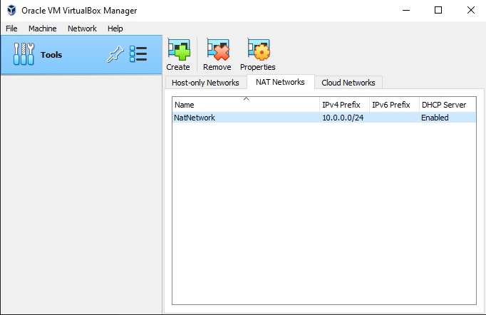
Screenshot: VirtualBox NAT Network, IPv4 prefix 10.0.0.0/24

2. Kali VM network adapter
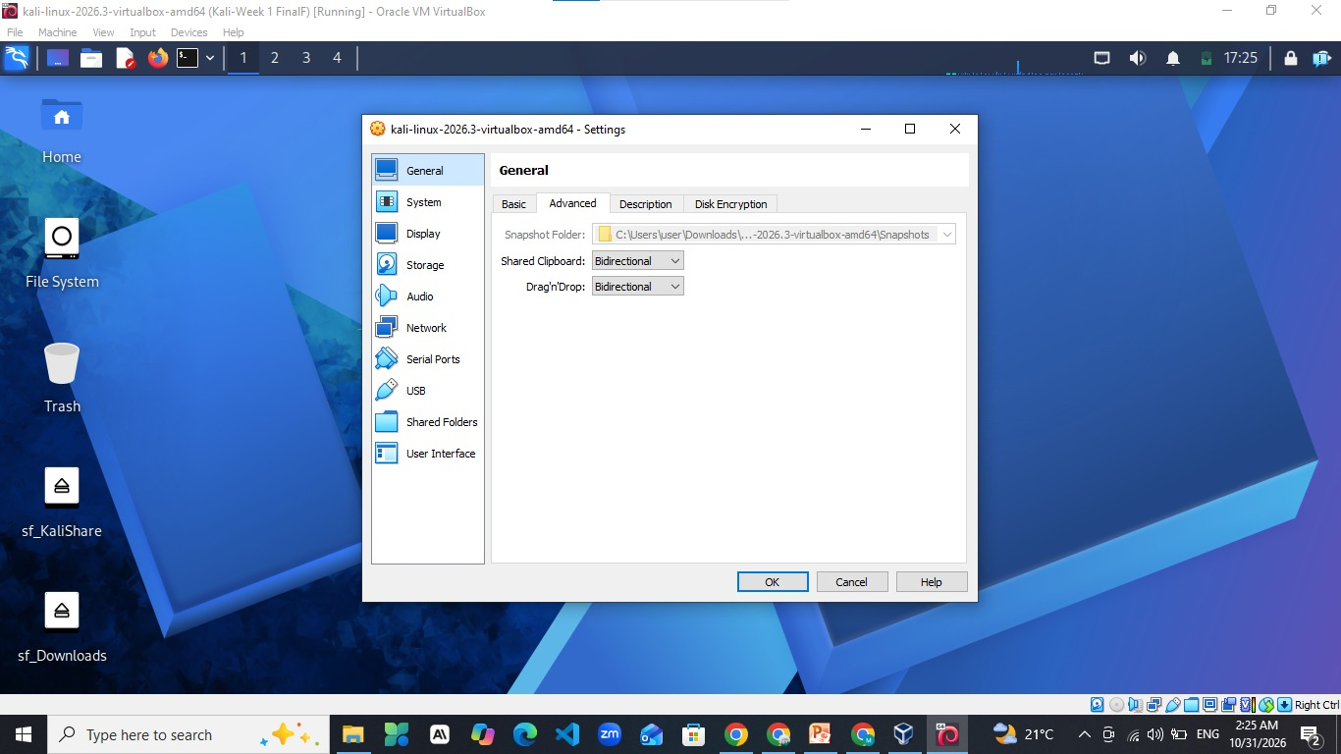
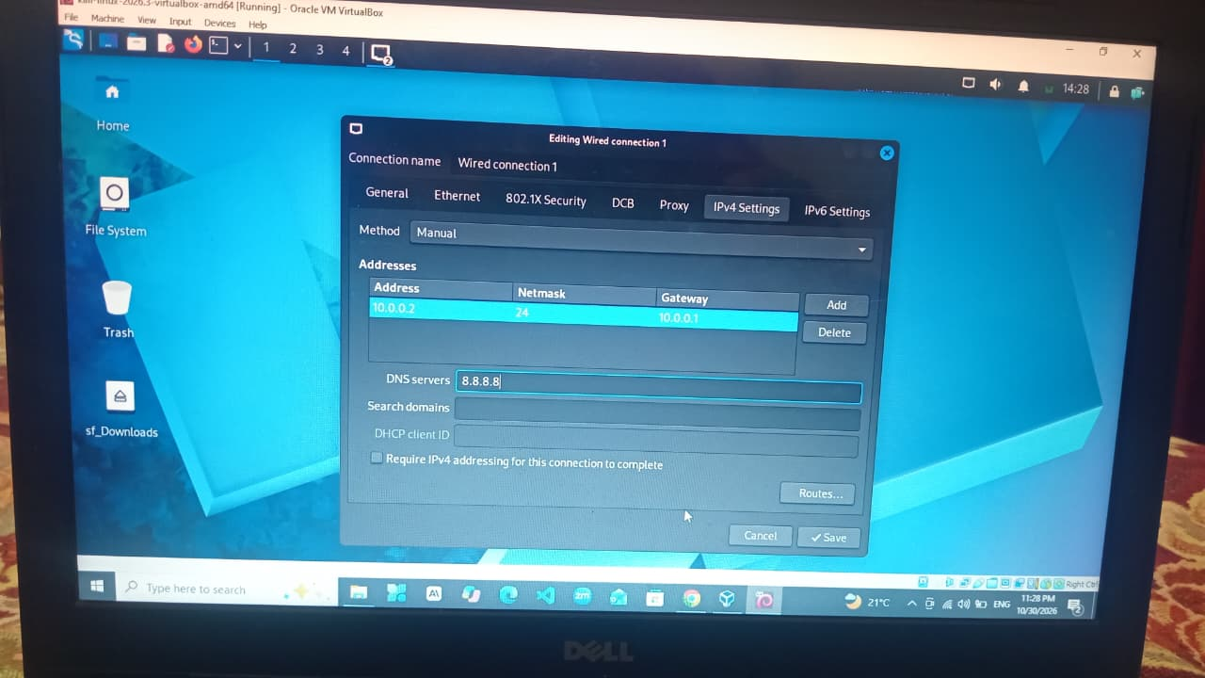
Screenshot: Adapter 1 attached to NAT Network (NatNetwork)

3. Kali IP address and Internet
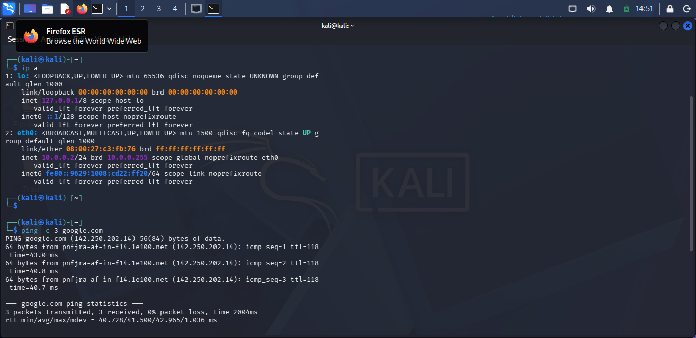
Screenshot: ip a showing 10.0.0.2/24 and successful ping google.com

4. Clipboard and drag and drop
Screenshot: General > Advanced set to Bidirectional

5. Shared folder
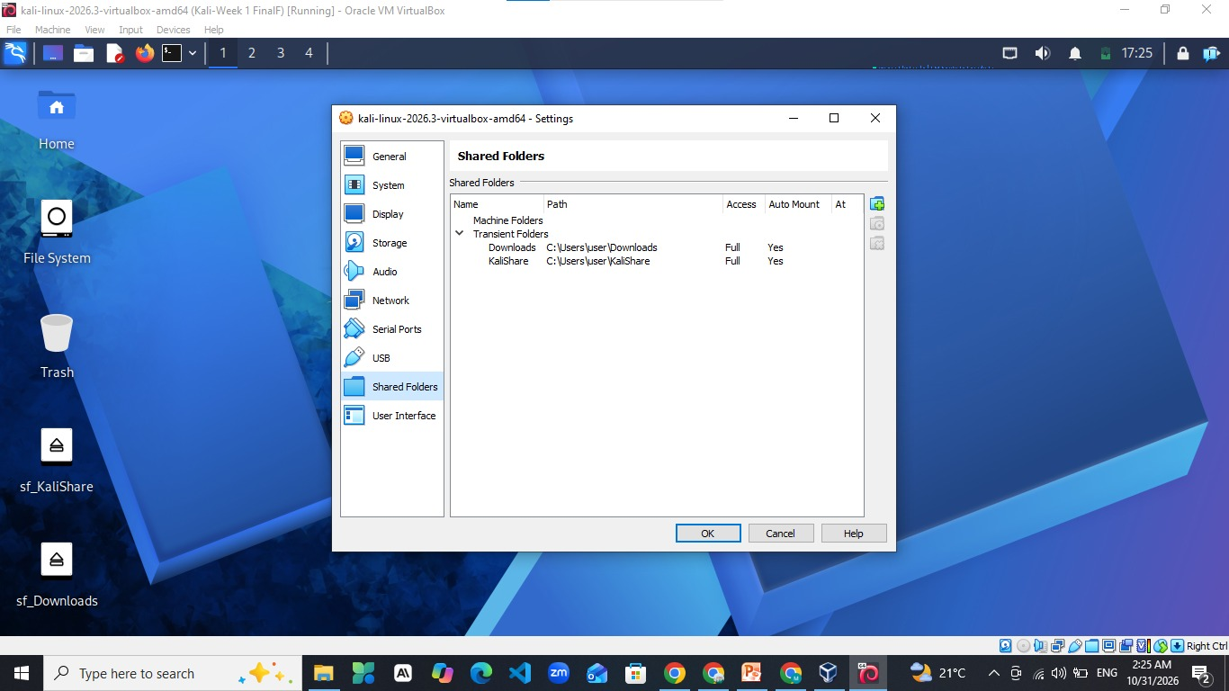
Screenshot: Shared Folders settings with Auto-mount

6. Snapshots
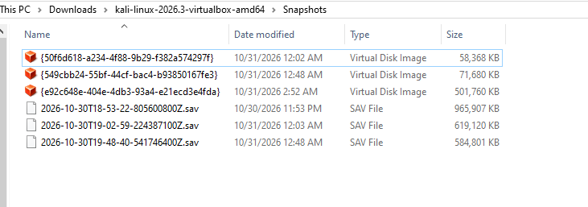
Screenshot: VirtualBox snapshot list

Part 2: Wireshark SOC Labs (Extra Module)
Six browser-based labs with ten tasks each. All analysis was done inside the provided labs.
Lab | Topic | Score
Lab 3 | Identify the Attacker's IP (port scan) | 80 / 100
Lab 4 | Follow TCP Stream 1 (plain text chat) | 99 / 100
Lab 5 | Follow TCP Stream, Part 2 (hidden data) | 99 / 100
Lab 6 | HTTP Plain Text Credentials | 100 / 100
Lab 7 | Catch the Brute Force Attacker | 100 / 100
Lab 8 | Catch the Call Scammer (VoIP) | 100 / 100

Lab 3: Identify the Attacker's IP
Scenario: a web server receives unusual traffic. Find the attack type and the attacker's IP.
Method: the filter tcp.flags.syn == 1 && tcp.flags.ack == 0 showed 55 packets, and 40 of them came from 192.168.10.66 to many different ports. Open ports replied with SYN, ACK (22, 80, 443) and closed ports replied with RST, ACK.
[ Click here and 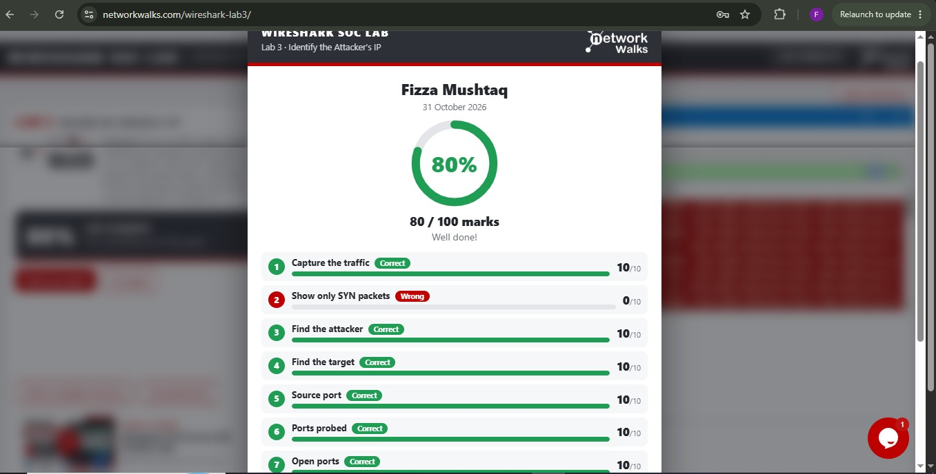
Screenshot: Lab 3 result page with score

Lab 4: Follow TCP Stream 1
Scenario: staff use an old plain text office chat tool. Read one chat and see what was shared.
Method: filtering out ports 80 and 443 left only port 5000. Right-click > Follow > TCP Stream opened the chat (tcp.stream eq 5). The chat contained passwords in plain text.
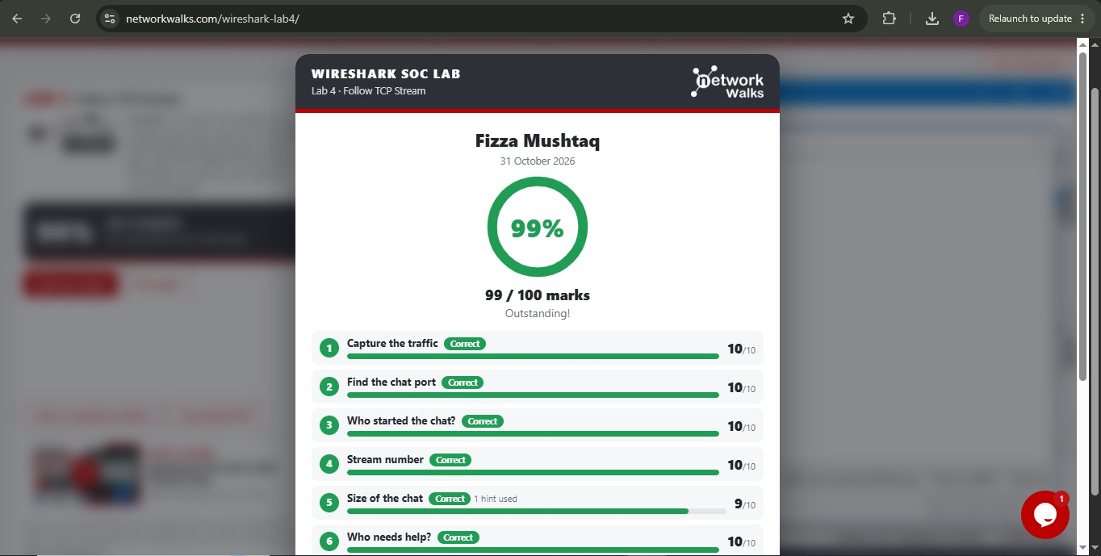
Screenshot: Lab 4 result page with score

Lab 5: Follow TCP Stream, Part 2
Scenario: a staff member browsed the company intranet and a secret is hidden in one of the pages.
Method: filter http.request listed the pages (/, /news.html, /status.html, /help.html, /events.html). Follow > TCP Stream on each page showed its content.
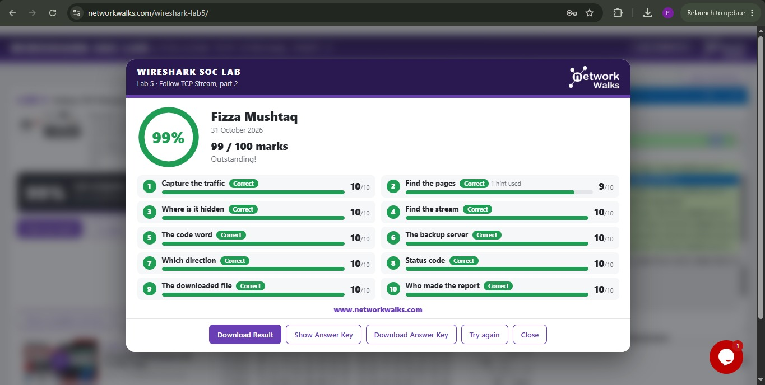
Screenshot: Lab 5 result page with score

Lab 6: HTTP Plain Text Credentials
Scenario: an old staff portal still runs on plain HTTP. Find what a person can read from an unencrypted sign-in.

[ Click he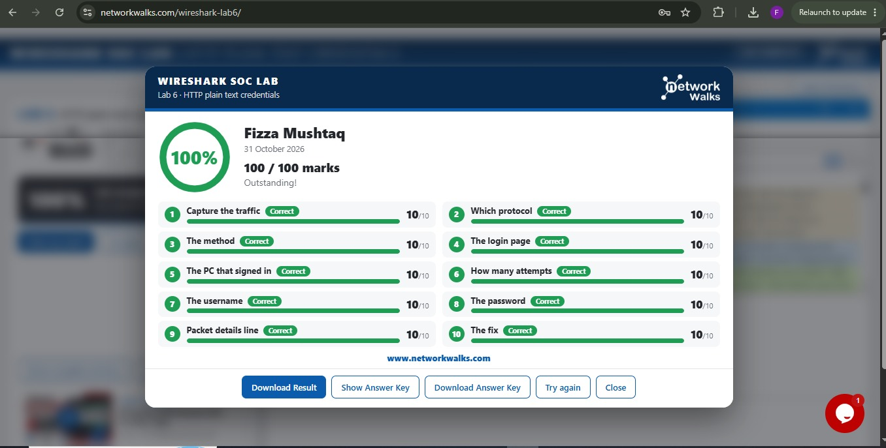
Screenshot: Lab 6 result page with score

Lab 7: Catch the Brute Force Attacker
Scenario: an FTP server owner reports many failed sign-ins. Find who is guessing passwords and whether the attacker got in.

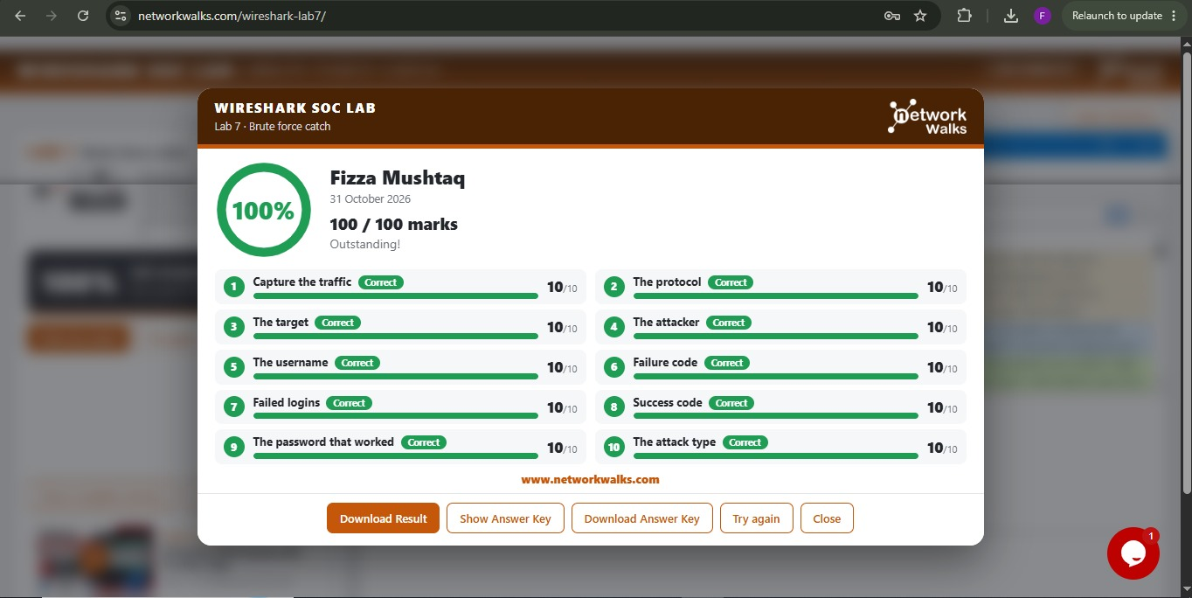
Screenshot: Lab 7 result page with score

Lab 8: Catch the Call Scammer
Scenario: a phone call was made through the company VoIP system. Find the call and play it back.

[ Click here and paste or insert your screen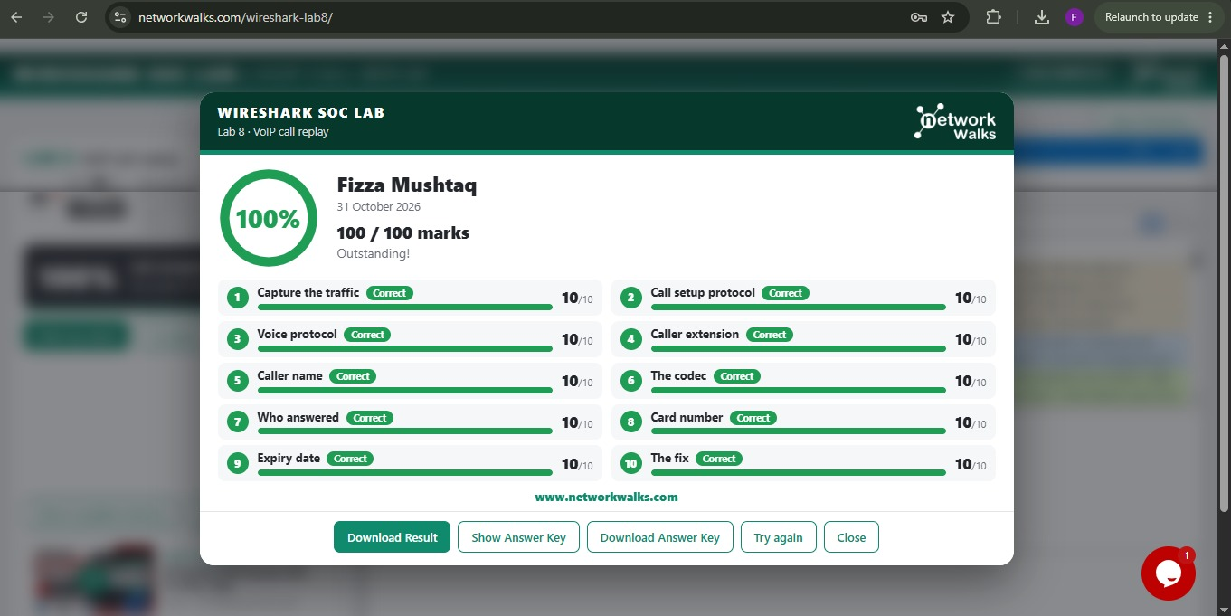
Screenshot: Lab 8 result page with score

Skills Practiced
- Display filters such as ip.addr, tcp.flags.syn, tcp.port and http.request
- Following TCP streams to read plain text conversations
- Spotting a TCP SYN port scan and telling open ports (SYN, ACK) from closed ports (RST, ACK)
- Finding credentials sent in clear text over HTTP
- Recognising brute force login patterns
- Analysing VoIP traffic

Main Takeaway
Unencrypted protocols such as HTTP, plain text chat, FTP and unencrypted VoIP expose passwords and conversations to anyone who can capture the traffic. The fix is encryption: HTTPS, SSH or SFTP, and SRTP for calls.

Practice Rules Followed
All traffic analysis was done inside the provided labs. The Kali VM is used only on my own isolated NAT Network, and I never tested or captured traffic on a network I do not own or have written permission to test.

